2023 Merchandise Request Form (Member Organisations)
Orders required by Tuesday May 9th
(Delivery is subject to stock availability and minimum orders from partners collectively)

Organisation Name:
Contact Name:
Contact Number:
Contact E-mail:
Address to Which Merchandise is to be sent:
Merchandise | Image | Quantity Required | Unit Cost | Total Cost
Drawstring Tote – with Carers Week  Logo | 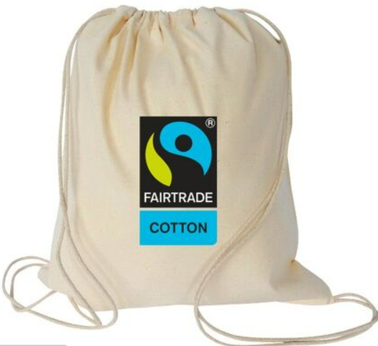 |  | €2.71
Soap Leaves – with Carers Week Logo | 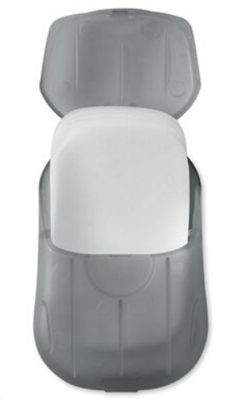 |  | €1.40
Fairtrade cotton tote bag with long handles | 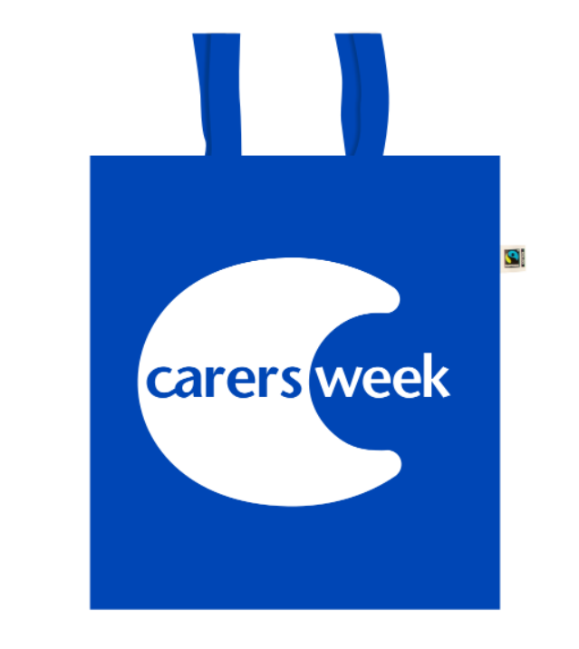 |  | €2.13
Blue Cooler Bag – with Carers Week Logo | 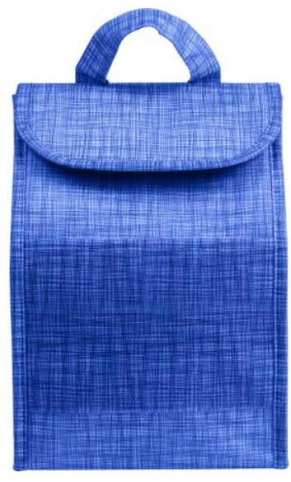 |  | €3.45
Lip balm – with Carers Week Logo | 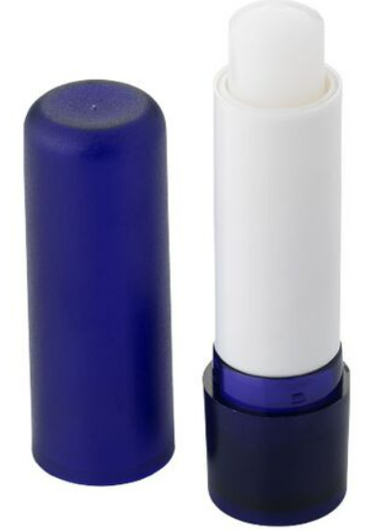 |  | €1.15
Toiletry Bag – with Carers Week Logo | 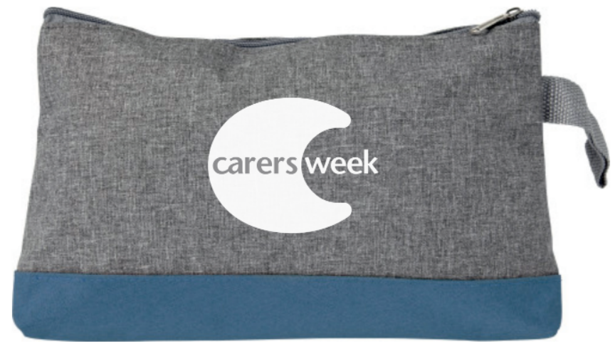 |  | €2.77
Recycled Notebook with Pen – with Carers Week Logo | 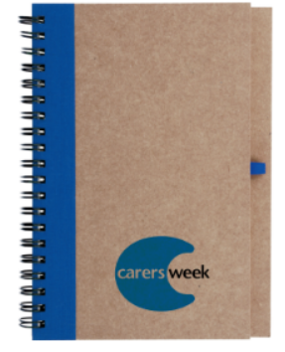 |  | €2.25
€1 and €2 Trolley Coins – with Carers Week Logo | 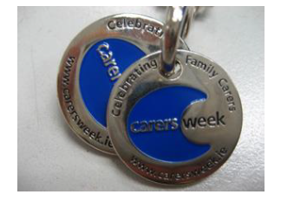 |  | €2.07
First Aid Pack – with Carers Week Logo | 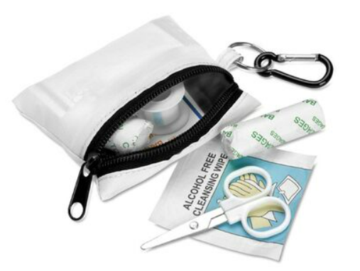 |  | €3.94
Balloons | 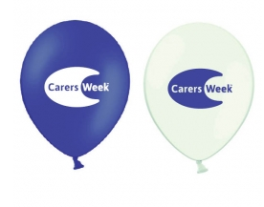 |  | 50c each
Mints - with Carers Week Logo | 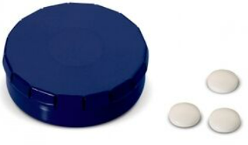 |  | €1.72
Total Cost

Please return the fully completed form by email to caroline@carealliance.ie by May 9th 2023.

